* 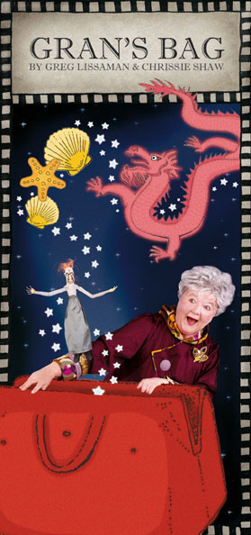 **GRAN’S BAG**
* **by Greg Lissaman and Chrissie Shaw**
* **Presented by SmallShows, GRAN’S BAG is a heartwarming and funny show by Greg Lissaman and Chrissie Shaw, for 3 to 10 year olds. This show is a fun experience for families, an ideal show for school holidays, festivals, schools, and touring.**

**THE SHOW**

* **When Gran comes to visit, she brings her beautiful big red bag. It is a treasure trove of secrets and small delights. All sorts of surprises emerge, and lots of great stories. The best story of all is about how Gran found her magic carpet bag – or did her bag find her?**
* **Chrissie Shaw brings the tale to life as the larger than life Gran and pulls the entire show out of her giant red handbag – which seems to have a life of its own. With storytelling, songs, and puppetry, Gran takes us on a fun adventure full of twists and turns. You never know where the story will go next.**
* *Gran’s Bag was a celebration of the power of the imagination, sensitively directed by Lissaman and performed with panache and charm by Shaw. The bag that opened to reveal a Chinese scene or Sydney apartment block, created a focus for young eyes and produced surprising events. The puppets; a cartwheeling Gran and the menacing Baba Yaga, and the delightfully sewn miniatures drew one into a Lilliputian world, safe, magical, mysterious and enchanting. Gran’s Bag was a magical carpet ride into a child’s imagination and an adult’s memorable journey into the delightful world of storytelling. Gran’s Bag’s simplicity was appealing, its design bewitching and its performance endearing. Peter Wilkins LOWDOWN August 2009.*

**COSTS for 2017 -2019**

**FOR THEATRE SEASONS:**

PER WEEK: $4695.00

Maximum of 2 performances daily with a 75-minute break between performances. Maximum 10 performances per week.

Fee does not include performer’s accommodation or travel.

Fee does not include royalties (10% GBO minus credit card charges and booking fees)

**FOR IN SCHOOLS PERFORMANCES:**

Per show: Minimum per session: $550.00, or $5.50 per child,

whichever is the greatest. Maximum audience: 120

**THE ARTISTS**

**Writer/Director Greg Lissaman**

* **Designers Imogen Keen & Hilary Talbot**
* **Composer/Performer Chrissie Shaw**
* **DURATION**

**50 minutes including Q and A**

**AVAILABILITY**

**Throughout 2017 - 2019**

**HISTORY TO DATE**

**Premiered at the State Library of QLD September 2008**

**Holiday season at The Street Theatre July 2009**

**Tour of Libraries for South East Arts Region, NSW July 2009**

**Schools shows at Riverside Theatres Parramatta 2009, 2013, Glen St Theatre 2010. NSW tour 2010, 2011, VIC 2011 Season at Tuggeranong Theatre Dec 2009. Season for Monkey Baa 2013. Schools in the ACT 2008 – 2016. Mittagong Playhouse Dec 2015**

**Season King Street Theatre Sept 2016**

**For further information and tech specs, contact:**

**Chrissie Shaw (SmallShows) Phone: 02 6247 2015**

**Mobile: 0407 079 748 Email:** [**chrissieshaw@apex.net.au**](mailto:chrissieshaw@apex.net.au)